National Career Development Association
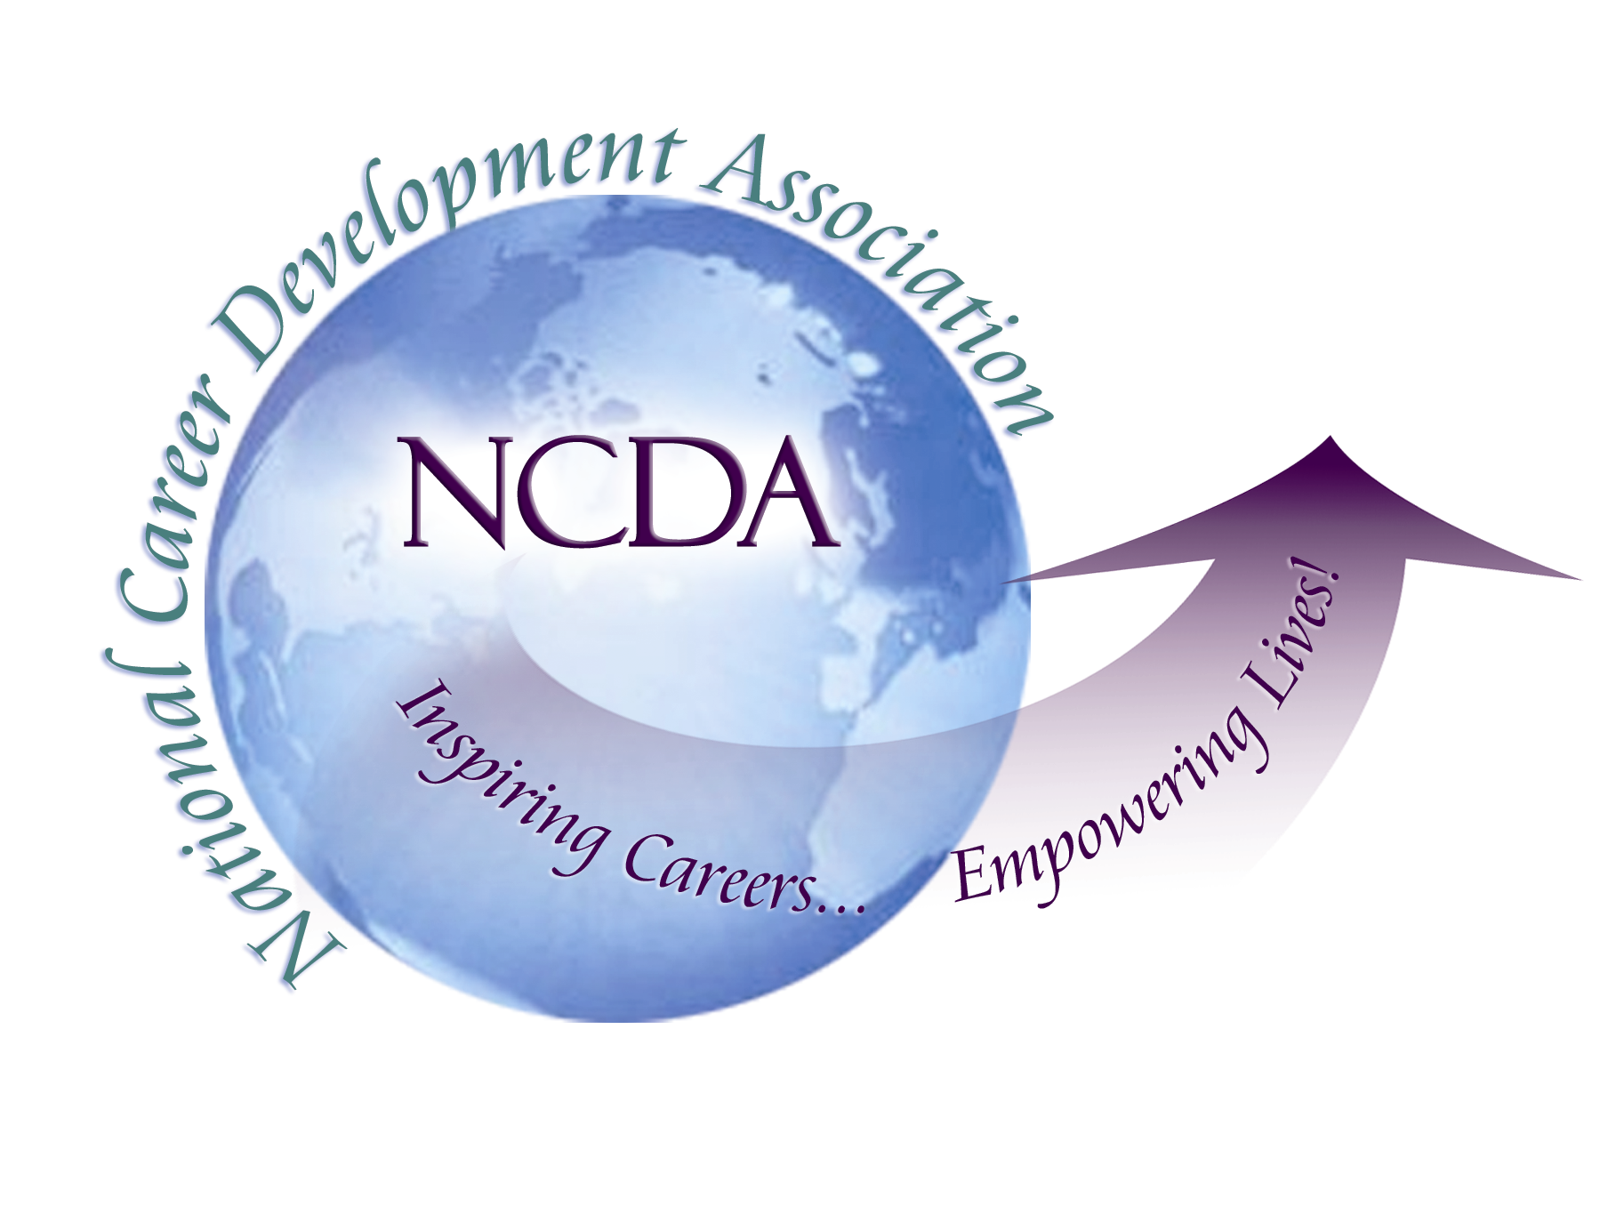
305 N. Beech Circle
Broken Arrow, OK 74012
918/663-7060
Fax: 918/663-7058
www.ncda.org

National Career Development Association
Leadership Academy
Action Learning Project Summary

Participant(s): Abiola Dipeolu

Board Mentor: Cheri Butler

Leadership Academy Class: LA VIII, 2013-2014

Project Title: Counseling Supervision with Career Development Emphasis

Project Description: The case for supervision of career development professionals has been convincingly made through the years. However, the lack of supervision of practicing career counselors continues to be reported. This project sought to 1) develop the profile of existing supervisors of career counseling, 2) assist with the development of curriculum modules for supervision with career development emphasis. The outcome of this project will help identify how NCDA could serve the growing needs of career counselor supervisors.

Summary/Conclusion:

The survey received a total of 62 responses ( 19% male; 80% female). Survey results indicated :
- Overwhelmingly, supervision is rated as highly important by a large number of the respondents.
- A large number reports several years of career counseling experience /background (10 years+).
- Large percentages of NCDA members are yet to receive training in supervision (46%).
- Large number reports membership in state association (62%)
- Sixty-two percent are supervisors-suggests benefits/need for training to address continuing development of supervisors.
- Six-five percent have not received training in supervision.
- Respondents indicated that training accessibility, affordability, location, and availability (online) will make supervision training attractive to supervisors.
- In terms of certification requirements for supervision, prior experience as a career ranked the highest followed by demonstrated understanding of career counseling concepts.
- Large number of respondents believe NCDA should take the lead in coordinating the certification.

Results/Recommendations:

The results suggested that:
- NCDA should take the lead in coordinating the supervision certification.
- Certification is better coordinated with the states/state boards.
- NCDA should update existing training packets to include components required by state licensure boards.
- NCDA should coordinate with states licensing boards to have this licensure approve as “Counseling Supervision Training with a Career Development Emphasis.”

