National Career Development Association

305 N. Beech Circle
Broken Arrow, OK 74012
918/663-7060
Fax: 918/663-7058
www.ncda.org

National Career Development Association
Leadership Academy
Action Learning Project Summary

Participant(s): Mr. Brian Calhoun and Dr. Melissa Wheeler

Board Mentor: Dr. Kevin Benet Stoltz and Dr. Cynthia Marco Scanlon

Leadership Academy Class: 2017

Project Title: Survey of Evaluation Competence of NCDA Higher Education Career Counselors & Specialists Constituency Group Members

Project Description: The focus of this research project was to examine the self-reported evaluation competency of members of the National Career Development Association (NCDA) who self-identified as members of the Higher Education Career Counselors & Specialists Constituency group. The purpose of the study was to assess members' self-reported competence in areas of research and program evaluation as part of their professional work and the types of data they collect for their institution. Results of this survey are designed to inform NCDA of the research and program evaluation training needs and preferences of NCDA members.

Summary/Conclusion:

We prepared a survey for use with the Higher Education Career Counselors & Specialists Constituency group (see Appendix C). The survey included 11 demographic questions (including questions about their place of employment, program evaluation data collected at their place of employment, and interest in training specific to research and program evaluation) and 26 questions modified from the Effective Practices Survey (Maras, Coleman, Gysbers, Herman & Stanley, 2016) concerning the self-assessed competencies of using career center data for research and program evaluation. The Effective Practices Survey includes nineteen, Likert-type scale response questions that researchers have previously been used to examine the program evaluation competence of school counselor and includes language about program evaluation, a key component missing from many research self-efficacy measures.

To modify the Effective Practices Survey, we received permission from the author to change the language of questions to reflect the practices and language used by higher education professionals. We also used the “Multi-cultural Career Counseling Minimum Competencies” and the “Career Counselor Assessment and Evaluation Competencies” found on the NCDA Standards webpage (https://ncda.org/aws/NCDA/pt/sp/guidelines ) to align the language in the survey and to ensure we covered questions reflecting the NCDA identified minimum research and program evaluation competencies for practitioners. We developed a 26 question, Likert-type scale (1- very unconfident/strongly disagree to 6- very confident/strongly agree) to be included in our survey as the Modified Effective Practices Survey.

We recruited participants via email from the Higher Education Career Counselors & Specialists Constituency Group of NCDA. The survey email was opened by 674 members with 75 members completing the demographics portion of the survey but only 24 of the 75 members completing the full survey including the Modified Effective Practices Survey. The data collected through the survey was limited in size and not fully complete (see Appendix A).

Further, we had difficulty aligning the Effective Practices Survey (Maras et al., 2016) to the NCDA research and program evaluation minimum standards and competencies in light of the documents on the NCDA Standards page. For instance, the language in the “Multi-cultural Career Counseling Minimum Competencies” was very broad and did not list specific tasks/knowledge related to research and program evaluation that members should demonstrate. In fact, the research/evaluation area contains one bullet point. Furthermore, the “Career Counselor Assessment and Evaluation Competencies” seems to be aimed to provide competencies individual counselors should display when using assessments with individual clients. Competency 8 in this document does provide a general overview of competence for career counselors using data for program and intervention evaluation and we were able to use this competency to align some of the language in the Effective Practices Survey (Maras et al., 2016) to reflect knowledge for career practitioners. However, this language seems to cover evaluation of programs and individual interventions and provides little guidance around other forms of practitioner research. Finally, we found a copy of the “Career Counseling Minimum Competencies” on the NCDA Standards page; this document indicated members should use the “Multi-cultural Career Counseling Minimum Competencies” in lieu of the presented standards given the multi-cultural standards replaced this document. We found this to be confusing and other members searching for NCDA’s research and program evaluation competencies may find it difficult to locate this information.

Results/Recommendations:

As previously stated, the data gathered from the online survey is incomplete and interpretation is limited. Our first recommendation would be to work with the Research Committee and Leadership Academy participants to continue gathering data on the research and program evaluation competence of members. This survey can be used as a starting point to create a survey that could measure these competencies in all constituency groups. With this information, the Research Committee can develop or oversee the development of specific trainings for NCDA members regarding practitioner-based research and program evaluation.

We have developed a list of other recommendations based on the responses we did receive and the lessons we learned during the process. Results from the survey indicate an average score of 2.04 (probably yes) when participants were asked if they would be interested in more training regarding research and program evaluation. When asked if participants would attend educational sessions or conference workshops concerning techniques and procedures for research and program evaluation, they responded with an average score of 2.16 (probably yes) that they would attend these sessions.

Q10 Are you interested in more training concerning research and program evaluation?

Definitely yes | Probably yes | Might or might not | Probably not | Definitely not
25 | 30 | 12 | 8 | 0

Q11 Would you attend educational sessions or pre-post/conference workshops concerning techniques and procedures for research and program evaluation?

Definitely yes | Probably yes | Might or might not | Probably not | Definitely not
18 | 32 | 20 | 5 | 0

Based on responses to the Modified Effective Practices Survey, topics for webinars and presentations could include the following based on participants’ reported lower levels of self-confidence:
- Use of t-tests and repeated measures designs to evaluate career center program activities. (mean score of 3.04- slightly unconfident)
- Use of repeated measures designs to evaluate career center program activities. (mean score of 3.46)
- Use of correlations to evaluate career center program activities. (mean score of 3.71)
- Use of descriptive statistics (means, standard deviations, percentages) to evaluate personal career center program activities. (mean score of 3.83)
- Use of technology (e.g., EZ Analyze, Excel, SPSS) to manage and use data (e.g., create graphs, create databases). (mean score of 3.83)

Our recommendations would be that the NCDA Research Committee create or solicit proposals for a conference presentation or pre-conference session on effective use of research and program evaluation within the career development setting. The Research Committee could also develop a series of webinars or conference presentations covering specific research methodology or program evaluation skills needed by practitioners. NCDA could also highlight conference presentations featuring research training or research studies developed and implemented by practitioners. This would raise awareness to the need for more practitioner-based research in our field.

Finally, we propose that NCDA revisit the information found in the “Multi-cultural Career Counseling Minimum Competencies” and the “Career Counselor Assessment and Evaluation Competencies” to ensure standards for research and program evaluation competencies are consistent and clearly stated to assist members in their understanding of the skills necessary to be a competent career practitioner in these areas.

Appendix A: Descriptive Statistics of Selected Questions
Question | N | Mean | Standard Deviation
Are you interested in more training concerning research and program evaluation? | 75 | 2.04 | .965
Would you attend educational sessions or pre-post/conference workshops concerning techniques and procedures for research and program evaluation? | 75 | 2.16 | .871
I can use career center data (demographics, coaching appointments, resume reviews, etc.) to identify specific needs of the diverse populations served by our career center. | 24 | 4.67 | 1.341
I can use institutional data (demographics, majors select, etc.) to identify specific needs of the diverse population served by our career center. | 24 | 4.46 | 1.444
I can access career center (demographics, coaching appointments, resume reviews, etc.) to identify specific needs of the diverse populations served by our career center. | 24 | 4.62 | 1.345
I can access institutional data (demographics, majors selected, etc.) to identify specific needs of the diverse populations served by our career center. | 24 | 4.25 | 1.567
I can use career center data to inform career center programming activities. | 24 | 5.00 | 1.022
I can use institutional data to inform career center programming activities. | 24 | 4.37 | 1.469
I can change my practice based on research and best practices related to the diverse populations our career center serves. | 24 | 4.63 | 1.135
I can develop an effective evaluation to improve my individual programs/services. | 24 | 4.58 | 1.283
I can develop an effective evaluation to improve my group programs/services. | 24 | 4.79 | 1.103
Q21 I can create a presentation to share my evaluation results with stakeholders. | 23 | 4.87 | 1.217
I can access research and best practices related to my practice that is applicable to the diverse populations our career center serves. | 23 | 4.48 | 1.410
My career center programming includes measurable goals and objectives. | 24 | 4.58 | 1.442
I can access and understand career assessment information (i.e., group norms, reliability, validity) for the purpose of choosing assessments for diverse clients. | 24 | 4.46 | 1.444
I can use appropriate statistics to evaluate the extent to which my activities and career center programming accomplishes the immediate goals and objectives of the career center. | 24 | 4.50 | 1.285
I can use evaluation results to modify the techniques I use to better assist the diverse clients served by my career center. | 24 | 4.62 | 1.209
I can describe how my career center activities and programs align with my institution’s goals. | 24 | 4.92 | 1.139
I can use data to evaluate individual and group interventions with students. | 24 | 4.33 | 1.435
I can use institutional data to help plan career programming activities and interventions (in conjunction with other career center staff) to meet the diverse needs of my clients. | 23 | 4.26 | 1.544
I can design outcome evaluations to explore the effects of career center interventions on client’s career development and decision making. | 24 | 4.17 | 1.606
I can use t-tests and repeated measures designs to evaluate career center program activities. | 24 | 3.04 | 1.681
I can use repeated measures designs to evaluate career center program activities. | 24 | 3.46 | 1.744
I can use correlations to evaluate my career center program activities. | 24 | 3.71 | 1.781
I can use descriptive statistics (means, standard deviations, percentages) to evaluate my career center program activities.. | 24 | 3.83 | 1.926
I know how to use technology (e.g., EZ Analyze, Excel, SPSS) to manage and use data (e.g., create graphs, create databases). | 24 | 3.83 | 1.880
I believe evaluation is an important ongoing activity of career center personnel to ensure a culturally-sensitive environment for all students. | 24 | 5.54 | .658
I believe evaluation leads to better student outcomes. | 24 | 5.75 | .532

Appendix B: Survey Questions and Responses

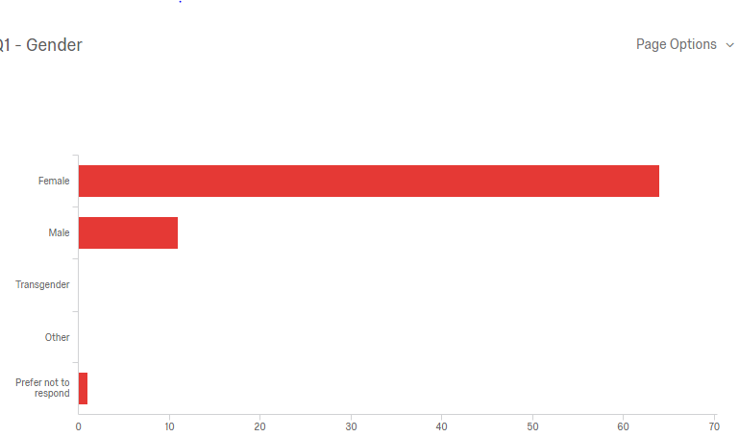
Question of Gender: 64 Female, 11 Male, 1 prefer not to Answer (N = 76)

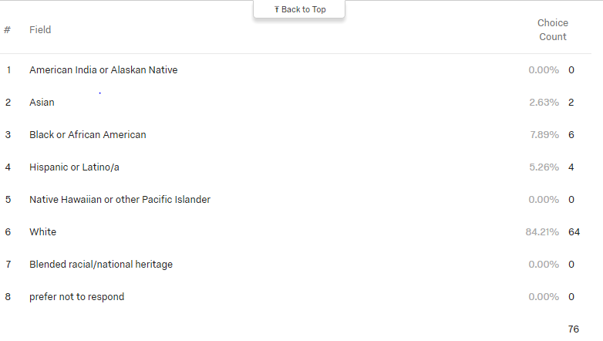

Question: Did you attend a cacrep accredited institution:

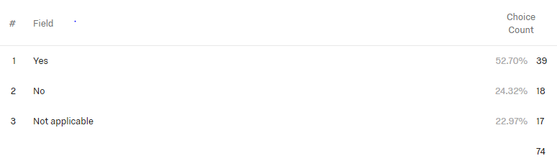

Question: Your field of Work
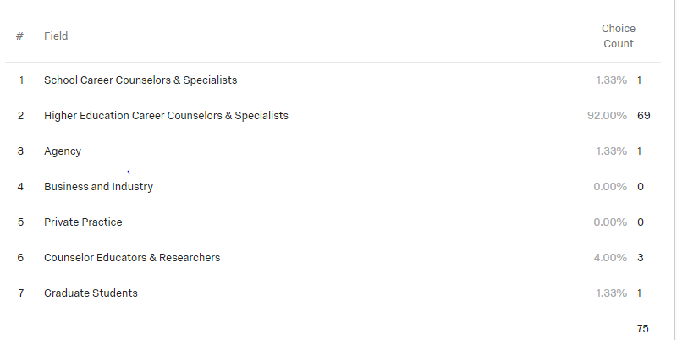

Question: Your workplace

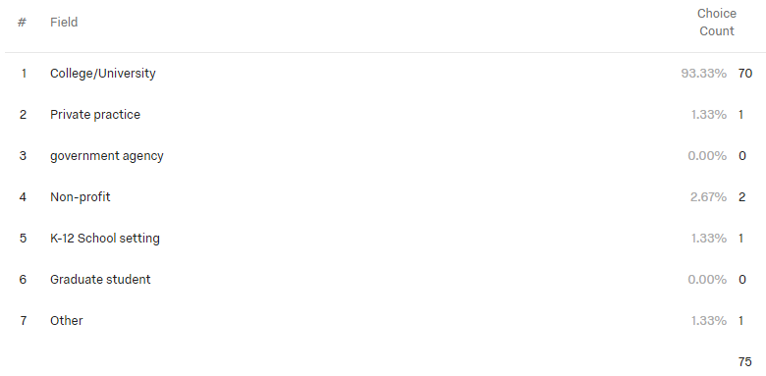

Question: Primary target Audience

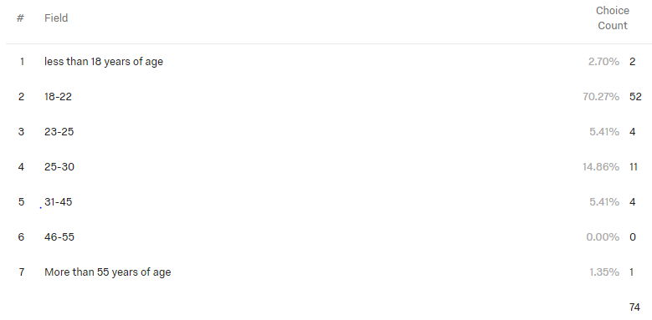Q10 - Are you interested in more training concerning research and program evaluation?

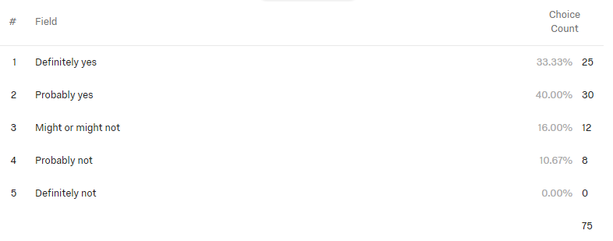

Q11 - Would you attend educational sessions or pre-post/conference workshops concerning techniques and procedures for research and program evaluation?

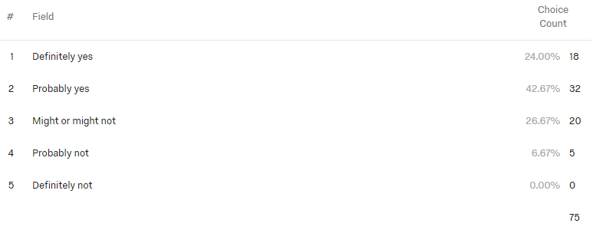

Q12 - I can use career center data (demographics, coaching appointments, resume reviews, etc.) to identify specific needs of the diverse populations served by our career center.

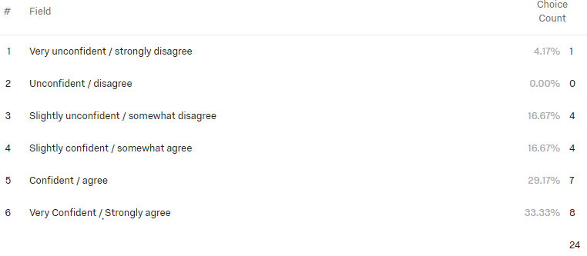
Q13 - I can use institutional data (demographics, majors select, etc.) to identify specific needs of the diverse population served by our career center.

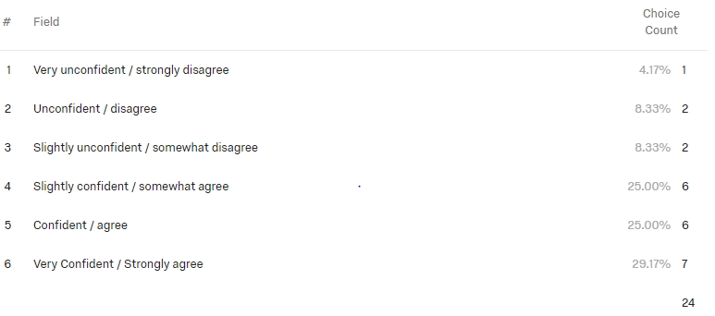

Q14 - I can access career center (demographics, coaching appointments, resume reviews, etc.) to identify specific needs of the diverse populations served by our career center.
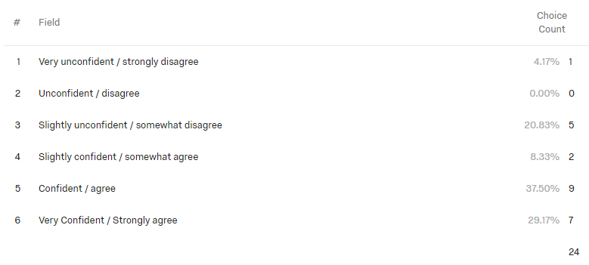

Q15 - I can access institutional data (demographics, majors selected, etc.) to identify specific needs of the diverse populations served by our career center. (separate career center data and institutional data)
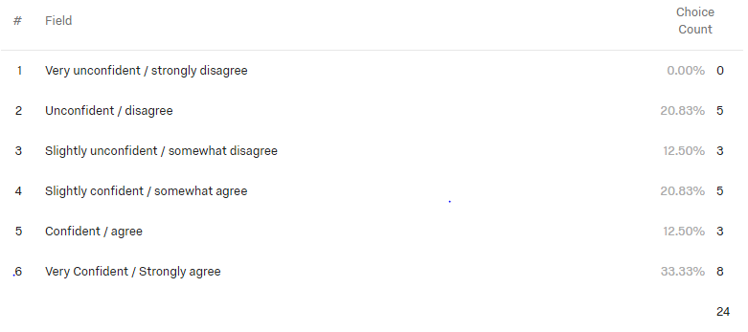
Q16 - I can use career center data to inform career center programming activities.
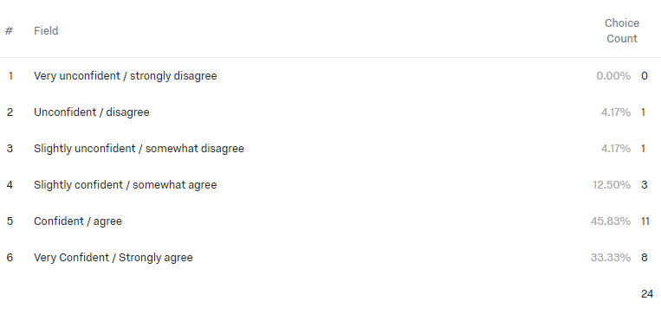

Q17 - I can use institutional data to inform career center programming activities.

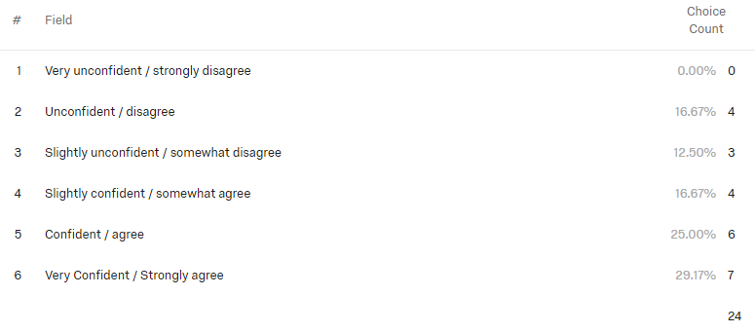
Q18 - I can change my practice based on research and best practices related to the diverse populations our career center serves.

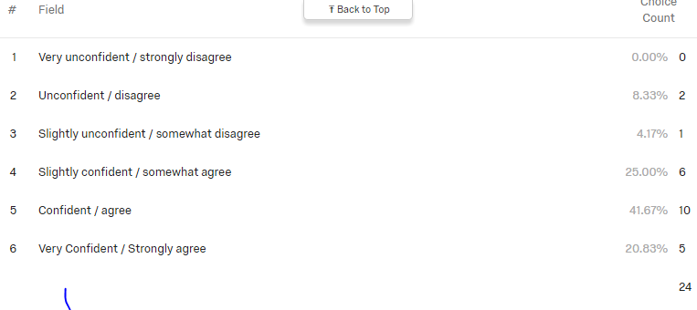

Q19 - I can develop an effective evaluation to improve my individual programs/services.
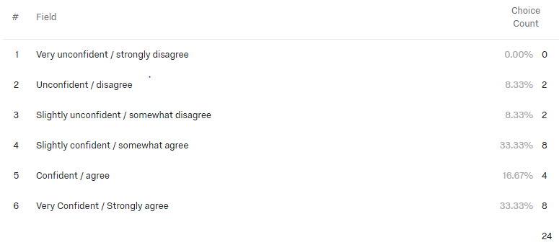

Q20 - I can develop an effective evaluation to improve my group programs/services.

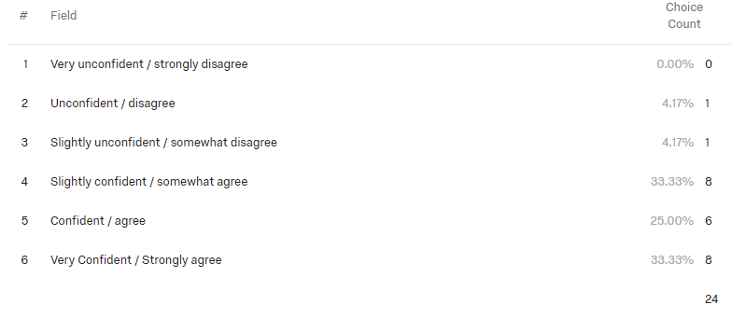

Q21 - I can create a presentation to share my evaluation results with stakeholders.
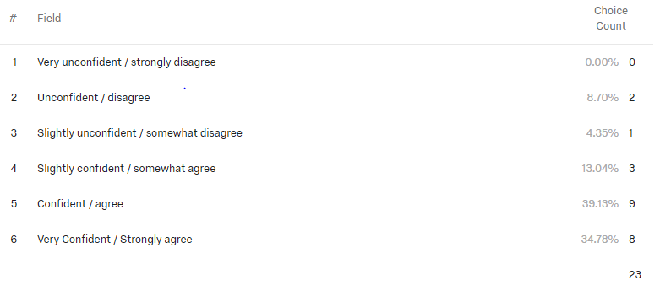
Q22 - I can access research and best practices related to my practice that is applicable to the diverse populations our career center serves.
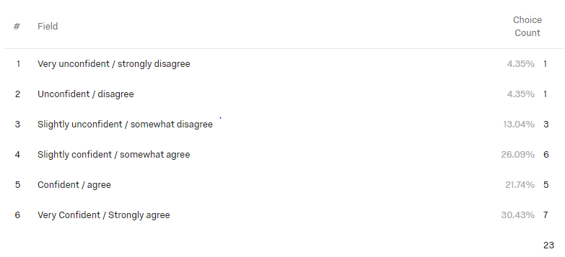

Q23 - My career center programming includes measurable goals and objectives.

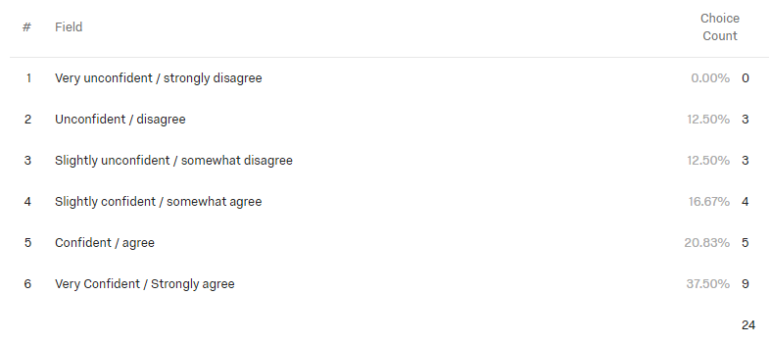
Q24 - I can access and understand career assessment information (i.e., group norms, reliability, validity) for the purpose of choosing assessments for diverse clients.
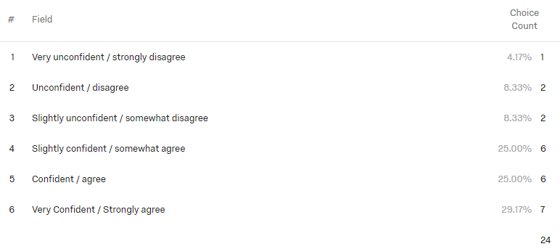
Q25 - I can use appropriate statistics to evaluate the extent to which my activities and career center programming accomplishes the immediate goals and objectives of the career center.

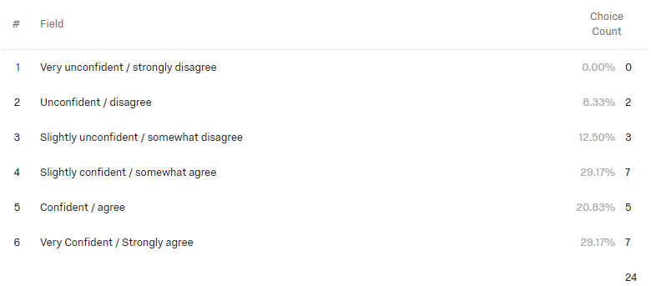

Q26 - I can use evaluation results to modify the techniques I use to better assist the diverse clients served by my career center.

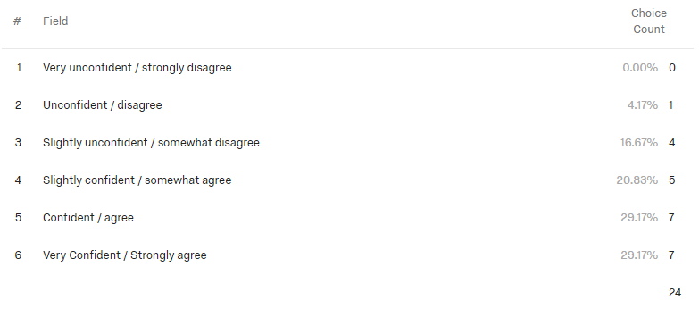

Q27 - I can describe how my career center activities and programs align with my institution’s goals.

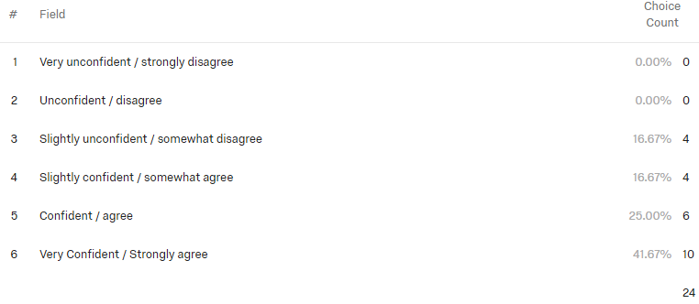
Q28 - I can use data to evaluate individual and group interventions with students.
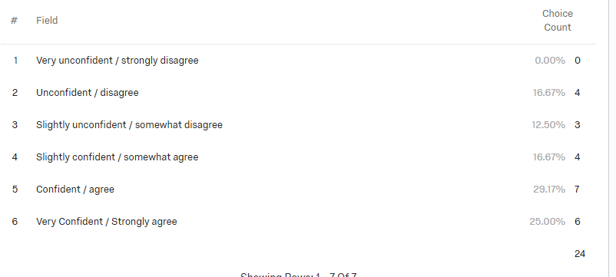

Q29 - I can use institutional data to help plan career programming activities and interventions (in conjunction with other career center staff) to meet the diverse needs of my clients..

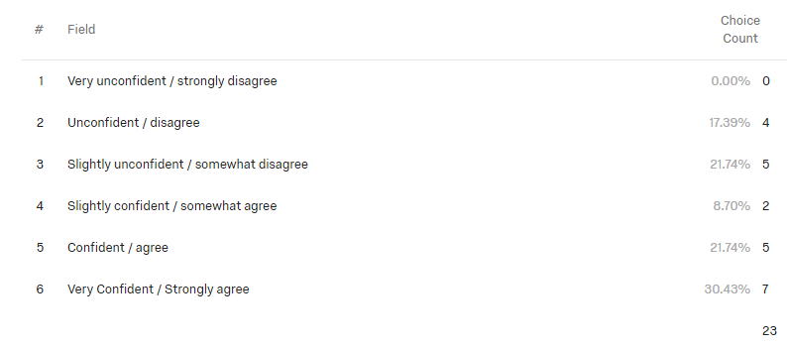
Q30 - I can design outcome evaluations to explore the effects of career center interventions on client’s career development and decision making.

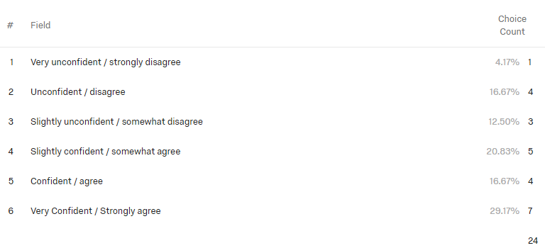

Q31 - I can use t-tests and repeated measures designs to evaluate career center program activities.
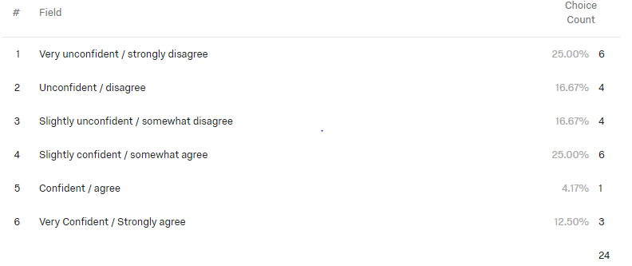

Q32 - I can use repeated measures designs to evaluate career center program activities.

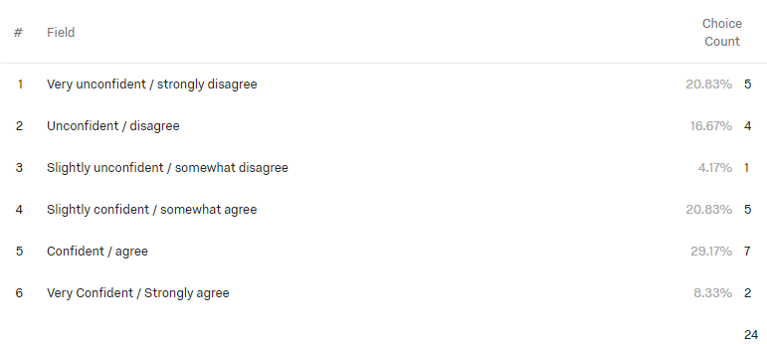
Q33 - I can use correlations to evaluate my career center program activities.

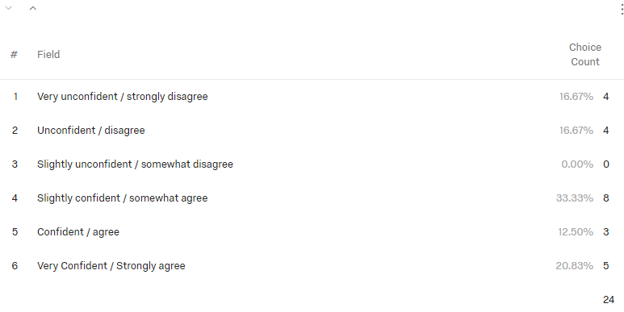
Q34 - I can use descriptive statistics (means, standard deviations, percentages) to evaluate my career center program activities..
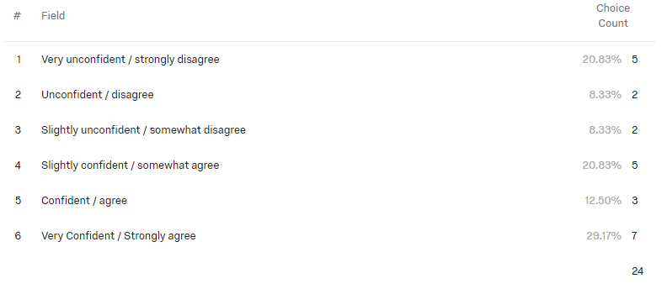

Q35 - I know how to use technology (e.g., EZ Analyze, Excel, SPSS) to manage and use data (e.g., create graphs, create databases).

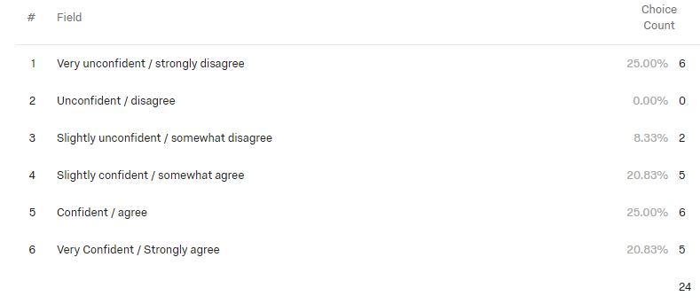
Q36 - I believe evaluation is an important ongoing activity of career center personnel to ensure a culturally-sensitive environment for all students.
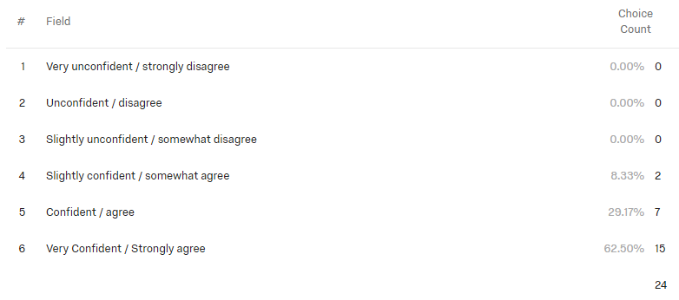
Q37 - I believe evaluation leads to better student outcomes. 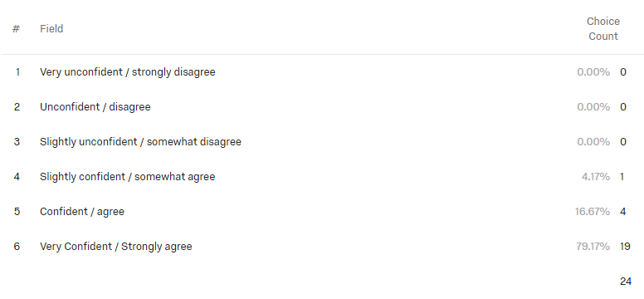
Appendix C: Complete Survey

Survey of Evaluation Competence of NCDA Higher Education Career Counselors & Specialist Constituency

Informed Consent Project Title: Survey of Evaluation Competence of NCDA Higher Education Career Counselors & Specialists Constituency Group Members What is the study about? This is a research project examining the evaluation competency of members of the National Career Development Association (NCDA) who self-identify as members of the Higher Education Career Counselors & Specialists Constituency group. This survey will assess members' self-reported collection of research data and competence in areas of research and program evaluation at their place of employment. Results of this survey will help inform research and program evaluation needs of NCDA members and future member needs assessment in this area. Why are you asking me? You are an NCDA member who has self-identified as a member of the Higher Education Career Counselors & Specialist Constituency group. What will you ask me to do if I agree to be in the study? As a participant, you will be asked to complete an online survey asking your self-reported confidence on items related to research and program evaluation. You will also be asked to provide brief demographic data, however, you will not be asked to identify your name or place of employment. The survey should take twenty minutes to complete. Is there any audio/video recording? No. What are the dangers to me? You will not be subject to any physical danger by taking part in this study. There is limited risk of emotional distress due to the questions in the assessment. If you have questions, want more information or have suggestions, please feel free to contact Melissa Wheeler at melissa.wheeler@lamar.edu or Brian Calhoun at calhoubm@wfu.edu. If you have any concerns about your rights, how you are being treated, concerns or complaints about this project or benefits or risks associated with being in this study please contact the Office of Research and Sponsored Programs Administration at rspa@lamar.edu. Are there any benefits to me for taking part in this research study? By participating in this study, you will be given the opportunity to rate your confidence in relation to common tasks associated with research and program evaluation at your site of employment. Are there any benefits to society as a result of me taking part in this research? The study may enable us to learn more about the self-reported research and program evaluation confidence of NCDA Higer Education Career Counselors & Specialists Constituency group as well as to develop targeted training and presentations to meet the needs of this group. Will I get paid for being in the study? Will it cost me anything? There are no costs to you for participating in this study. At the end of the study, you will be given the option of entering your email address to be entered into a random drawinf for one $50 Amazon gift card. How will you keep my information confidential? Your answers to survey questoins in this study will be collected through Qualtrics. All digital data will be password protected and kept on the investigators' computers. No identifiable information will be collected as part of this study so the risk of confidentiality being breached is minimal. When providing your email address for the gift card drawing, you will be directed to a separate site where you can enter your email address. Your email address will have no connection to the survey data you provided. All information obtained in this study is strictly confidential unless disclosure is required by law. What if I want to leave the study? You have the right to refuse to participate or to withdraw at anytime, without penalty. If you do withdraw, it will not affect you in any way. If you choose to withdraw, you may request that any of your data which has been collected be destroyed unless it is in a de-identifiable state. What about new information/changes in the study? If signficant new information relating to the study becomes available which may relate to your willingness to continue to participate, this information will be distributed by the researchers to the NCDA Higher Education Career Counselors & Specialists Constituency group. Voluntary Consent by Participant: Byparticipating in this study, you agree that you have been informed of the nature, risks, and benefits of this study, you fully understand the nature of the study and risks involved and are openly willing consent to take part in this study. all of your questions concerning this study have been answered. You are also agreeing that you are 18 years of age or older and are able to give consent to participate in this study. Consent to participate in research:I have read the above and have received satisfactory answers to my questions. I understand that by clicking "Yes" and continuing with the survey, I am agreeing to voluntarily participate in this research study.

- Yes (1)

Begin: Demographic Questions

Q1 Gender
- Female (1)
- Male (2)
- Transgender (3)
- Other (4)
- Prefer not to respond (5)

Q2 Please enter your numeric age (leave blank if prefer not to respond)

Q3 Ethnicity (please choose all that apply)
- American India or Alaskan Native (1)
- Asian (2)
- Black or African American (3)
- Hispanic or Latino/a (4)
- Native Hawaiian or other Pacific Islander (5)
- White (6)
- Blended racial/national heritage (7)
- prefer not to respond (8)

Q4 Degrees held and major/focus (please include all)

Q5 Did you graduate with a degree from Cacrep accredited institution?
- Yes (1)
- No (2)
- Not applicable (3)

q6 Constituency Group (choose group/groups that are applicable)
- School Career Counselors & Specialists (1)
- Higher Education Career Counselors & Specialists (2)
- Agency (3)
- Business and Industry (4)
- Private Practice (5)
- Counselor Educators & Researchers (6)
- Graduate Students (7)

Q7 Current Employment Setting
- College/University (1)
- Private practice (2)
- government agency (3)
- Non-profit (4)
- K-12 School setting (5)
- Graduate student (6)
- Other (7)

Q8 Do you currently collect data for program evaluation at your employment setting? if yes, how do you use this data (be as brief or as detailed as you would like)?

Q9 What is your primary target audience in your career center?
- less than 18 years of age (1)
- 18-22 (2)
- 23-25 (3)
- 25-30 (4)
- 31-45 (5)
- 46-55 (6)
- More than 55 years of age (7)

Q10 Are you interested in more training concerning research and program evaluation?
- Definitely yes (1)
- Probably yes (2)
- Might or might not (3)
- Probably not (4)
- Definitely not (5)

Q11 Would you attend educational sessions or pre-post/conference workshops concerning techniques and procedures for research and program evaluation?
- Definitely yes (1)
- Probably yes (2)
- Might or might not (3)
- Probably not (4)
- Definitely not (5)

Begin: Modified Effective Practices Survey Please rate your level of perceived confidence in demonstrating each of the following competencies regarding research and program evaluation. Answer the questions to the best of your ability without spending a great deal of time analyizing the items. Please use the following scale when responding: 1 = very unconfident / strongly disagree 2 = unconfident / disagree 3 = slightly unconfident / somewhat disagree 4 = slightly confident / somewhat agree 5 = confident / agree 6 = very confident / strongly agree Throughout this suvey, "institutional data" refers to student demographics for your university as a whole to include but not limited to student demographics, majors selected, and degree level. "Career center data" refers to information related to student demongraphics, majors served, number of and type of appointments, and presentation attendance.

Q12 I can use career center data (demographics, coaching appointments, resume reviews, etc.) to identify specific needs of the diverse populations served by our career center.
- Very unconfident / strongly disagree (1)
- Unconfident / disagree (2)
- Slightly unconfident / somewhat disagree (3)
- Slightly confident / somewhat agree (4)
- Confident / agree (5)
- Very Confident / Strongly agree (6)

Q13 I can use institutional data (demographics, majors select, etc.) to identify specific needs of the diverse population served by our career center.
- Very unconfident / strongly disagree (1)
- Unconfident / disagree (2)
- Slightly unconfident / somewhat disagree (3)
- Slightly confident / somewhat agree (4)
- Confident / agree (5)
- Very Confident / Strongly agree (6)

Q14 I can access career center (demographics, coaching appointments, resume reviews, etc.) to identify specific needs of the diverse populations served by our career center.
- Very unconfident / strongly disagree (1)
- Unconfident / disagree (2)
- Slightly unconfident / somewhat disagree (3)
- Slightly confident / somewhat agree (4)
- Confident / agree (5)
- Very Confident / Strongly agree (6)

Q15 I can access institutional data (demographics, majors selected, etc.) to identify specific needs of the diverse populations served by our career center. (separate career center data and institutional data)
- Very unconfident / strongly disagree (1)
- Unconfident / disagree (2)
- Slightly unconfident / somewhat disagree (3)
- Slightly confident / somewhat agree (4)
- Confident / agree (5)
- Very Confident / Strongly agree (6)

Q16 I can use career center data to inform career center programming activities.
- Very unconfident / strongly disagree (1)
- Unconfident / disagree (2)
- Slightly unconfident / somewhat disagree (3)
- Slightly confident / somewhat agree (4)
- Confident / agree (5)
- Very Confident / Strongly agree (6)

Q17 I can use institutional data to inform career center programming activities.
- Very unconfident / strongly disagree (1)
- Unconfident / disagree (2)
- Slightly unconfident / somewhat disagree (3)
- Slightly confident / somewhat agree (4)
- Confident / agree (5)
- Very Confident / Strongly agree (6)

Q18 I can change my practice based on research and best practices related to the diverse populations our career center serves.
- Very unconfident / strongly disagree (1)
- Unconfident / disagree (2)
- Slightly unconfident / somewhat disagree (3)
- Slightly confident / somewhat agree (4)
- Confident / agree (5)
- Very Confident / Strongly agree (6)

Q19 I can develop an effective evaluation to improve my individual programs/services.
- Very unconfident / strongly disagree (1)
- Unconfident / disagree (2)
- Slightly unconfident / somewhat disagree (3)
- Slightly confident / somewhat agree (4)
- Confident / agree (5)
- Very Confident / Strongly agree (6)

Q20 I can develop an effective evaluation to improve my group programs/services.
- Very unconfident / strongly disagree (1)
- Unconfident / disagree (2)
- Slightly unconfident / somewhat disagree (3)
- Slightly confident / somewhat agree (4)
- Confident / agree (5)
- Very Confident / Strongly agree (6)

Q21 I can create a presentation to share my evaluation results with stakeholders.
- Very unconfident / strongly disagree (1)
- Unconfident / disagree (2)
- Slightly unconfident / somewhat disagree (3)
- Slightly confident / somewhat agree (4)
- Confident / agree (5)
- Very Confident / Strongly agree (6)

Q22 I can access research and best practices related to my practice that is applicable to the diverse populations our career center serves.
- Very unconfident / strongly disagree (1)
- Unconfident / disagree (2)
- Slightly unconfident / somewhat disagree (3)
- Slightly confident / somewhat agree (4)
- Confident / agree (5)
- Very Confident / Strongly agree (6)

Q23 My career center programming includes measurable goals and objectives.
- Very unconfident / strongly disagree (1)
- Unconfident / disagree (2)
- Slightly unconfident / somewhat disagree (3)
- Slightly confident / somewhat agree (4)
- Confident / agree (5)
- Very Confident / Strongly agree (6)

Q24 I can access and understand career assessment information (i.e., group norms, reliability, validity) for the purpose of choosing assessments for diverse clients.
- Very unconfident / strongly disagree (1)
- Unconfident / disagree (2)
- Slightly unconfident / somewhat disagree (3)
- Slightly confident / somewhat agree (4)
- Confident / agree (5)
- Very Confident / Strongly agree (6)

Q25 I can use appropriate statistics to evaluate the extent to which my activities and career center programming accomplishes the immediate goals and objectives of the career center.
- Very unconfident / strongly disagree (1)
- Unconfident / disagree (2)
- Slightly unconfident / somewhat disagree (3)
- Slightly confident / somewhat agree (4)
- Confident / agree (5)
- Very Confident / Strongly agree (6)

Q26 I can use evaluation results to modify the techniques I use to better assist the diverse clients served by my career center.
- Very unconfident / strongly disagree (1)
- Unconfident / disagree (2)
- Slightly unconfident / somewhat disagree (3)
- Slightly confident / somewhat agree (4)
- Confident / agree (5)
- Very Confident / Strongly agree (6)

Q27 I can describe how my career center activities and programs align with my institution’s goals.
- Very unconfident / strongly disagree (1)
- Unconfident / disagree (2)
- Slightly unconfident / somewhat disagree (3)
- Slightly confident / somewhat agree (4)
- Confident / agree (5)
- Very Confident / Strongly agree (6)

Q28 I can use data to evaluate individual and group interventions with students.
- Very unconfident / strongly disagree (1)
- Unconfident / disagree (2)
- Slightly unconfident / somewhat disagree (3)
- Slightly confident / somewhat agree (4)
- Confident / agree (5)
- Very Confident / Strongly agree (6)

Q29 I can use institutional data to help plan career programming activities and interventions (in conjunction with other career center staff) to meet the diverse needs of my clients..
- Very unconfident / strongly disagree (1)
- Unconfident / disagree (2)
- Slightly unconfident / somewhat disagree (3)
- Slightly confident / somewhat agree (4)
- Confident / agree (5)
- Very Confident / Strongly agree (6)

Q30 I can design outcome evaluations to explore the effects of career center interventions on client’s career development and decision making.
- Very unconfident / strongly disagree (1)
- Unconfident / disagree (2)
- Slightly unconfident / somewhat disagree (3)
- Slightly confident / somewhat agree (4)
- Confident / agree (5)
- Very Confident / Strongly agree (6)

Q31 I can use t-tests and repeated measures designs to evaluate career center program activities.
- Very unconfident / strongly disagree (1)
- Unconfident / disagree (2)
- Slightly unconfident / somewhat disagree (3)
- Slightly confident / somewhat agree (4)
- Confident / agree (5)
- Very Confident / Strongly agree (6)

Q32 I can use repeated measures designs to evaluate career center program activities.
- Very unconfident / strongly disagree (1)
- Unconfident / disagree (2)
- Slightly unconfident / somewhat disagree (3)
- Slightly confident / somewhat agree (4)
- Confident / agree (5)
- Very Confident / Strongly agree (6)

Q33 I can use correlations to evaluate my career center program activities.
- Very unconfident / strongly disagree (1)
- Unconfident / disagree (2)
- Slightly unconfident / somewhat disagree (3)
- Slightly confident / somewhat agree (4)
- Confident / agree (5)
- Very Confident / Strongly agree (6)

Q34 I can use descriptive statistics (means, standard deviations, percentages) to evaluate my career center program activities..
- Very unconfident / strongly disagree (1)
- Unconfident / disagree (2)
- Slightly unconfident / somewhat disagree (3)
- Slightly confident / somewhat agree (4)
- Confident / agree (5)
- Very Confident / Strongly agree (6)

Q35 I know how to use technology (e.g., EZ Analyze, Excel, SPSS) to manage and use data (e.g., create graphs, create databases).
- Very unconfident / strongly disagree (1)
- Unconfident / disagree (2)
- Slightly unconfident / somewhat disagree (3)
- Slightly confident / somewhat agree (4)
- Confident / agree (5)
- Very Confident / Strongly agree (6)

Q36 I believe evaluation is an important ongoing activity of career center personnel to ensure a culturally-sensitive environment for all students.
- Very unconfident / strongly disagree (1)
- Unconfident / disagree (2)
- Slightly unconfident / somewhat disagree (3)
- Slightly confident / somewhat agree (4)
- Confident / agree (5)
- Very Confident / Strongly agree (6)

Q37 I believe evaluation leads to better student outcomes.
- Very unconfident / strongly disagree (1)
- Unconfident / disagree (2)
- Slightly unconfident / somewhat disagree (3)
- Slightly confident / somewhat agree (4)
- Confident / agree (5)
- Very Confident / Strongly agree (6)

Q38 Thank you for participating in this study. If you wish to be entered into the drawing for a $50 Amazon gift card, please use this link to submit your email address: Click here for the link - detailed url is below https://wakeforest.qualtrics.com/SE/?SID=SV_bq2MzbJNOQd2NuZ

