NCDA School Counselors and Career Specialists Constituency
Advisory Council
2016-2017

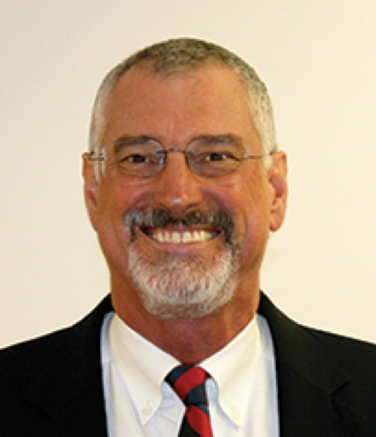
Ray Davis, Trustee, is formerly the Education Associate for Career Guidance in the Office of Career and Technology Education at the South Carolina Department of Education. He serves on the Board of Directors for the National Career Development Association (NCDA) as Trustee for School Counselors and Career Specialists. Ray earned his doctoral degree from the University of South Carolina (USC) in Educational Leadership and Policy with a focus on career development. He successfully led the movement for inclusion of the (NCDA) CDF curriculum in the Education and Economic Development Act of 2005. This resulted in South Carolina having the highest number of Global Career Development Facilitators in the nation enhancing delivery of high quality career development. Currently, Ray is the owner of Ray Davis Consulting. He has consulted with educational state agencies in Connecticut, Wyoming, Texas, Colorado, Missouri, and Arkansas, in addition to U.S. Army, ACT, USC Career Center, and RTI, Inc. He has worked with educators both nationally and internationally during his 38 years of work in education. His state career guidance program was cited in 2010 as “exemplary” by both the US Department of Education and also the EU’s The Organisation for Economic Co-operation and Development. In 2011, Ray was named a NCDA Fellow. The South Carolina Association for Career and Technology Education presented Ray with a Lifetime Achievement Award in 2013. Ray can be reached at 803-465-0521 (cell), 803-777-1951 (office), and xraydavis@gmail.com

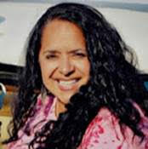

Mary Ellen Earnhardt has taught K-college; she has been involved with career counseling as an educator, college professor and most recently the Education Program Representative for the Office of Public Instructions in Montana. She believes that career development should be in all aspect of education and life. She received the NCDA Outstanding Career Practitioner Award in 2007-2008. She is the proud mother of two daughters, one who obtained her degree as an industrial designer and lives in San Francisco. Her youngest daughter is a medical lab technician in Minnesota. Her husband is a retired game warden and plays the bag pipes for the Pipes and Drums of the Black Devils. Mary Ellen can be reached at 406-444-3519 (office), 406461-7994 (cell), and MEarnhardt@mt.gov

Celeste Hall serves as the Career Coach Specialist for Workforce Development Services at the 23-college Virginia Community College System providing program support and training to high school and adult career coaches. She has spent most of her career in K-12 education, school counseling and career development.
She has worked as a member of the Career Development Facilitator Advisory Council to encourage the use of the Career Development Facilitator program to train educators so that they can increase the integration of career development into curriculum. She serves as Treasurer of the Virginia Career Development Association and Secretary of The Virginia Counselors Association Foundation. Celeste holds a B.A. in History from the College of William and Mary and M.Ed. in School Counseling from Virginia Commonwealth University, is a National Board Certified Teacher in the School Counseling area and a Career Development Facilitator Instructor. Celeste can be contacted at chall@vccs.edu and (804)393-0341.

Virginia “Ginger” Walsh Reijners is a School Counselor for the Berkeley County School District in South Carolina. Ginger works with middle and high school students on developing skills to achieve academic goals, manage social/emotional challenges and develop a career pathway. She is working to develop a career guidance program for the middle school she serves. Her primary goal is to teach students about the important connection between aspirations and academics. While an undergraduate at The University of South Carolina she became very interested in student development theory and the influence that educators have in the career choices of their students. During her career, Ginger completed additional graduate degrees in School Counseling from The Citadel and School Administration from Charleston Southern University. Phase one of her career in Higher Education and now phase 2 in secondary education have always included working with colleagues and systems, and most importantly students, to align instruction and program goals with maximizing each students’ achievements. Ginger can be reached at reijnersv@bcsdschools.net or 843-899-8786.

Angeliki “Angela” Bourassa is the Extended Learning Opportunities (ELO) Coordinator for Manchester High School Central in the Manchester, NH School District. The ELO program is a competency­based program designed to build a bridge between education and business to better prepare students for academic and vocational success. Before working in education, Angela was in the behavioral health field, where she served as one of the original employment specialists at the Mental Health Center of Greater Manchester using the supported employment model called Individual Placement and Support. In addition to vocational work, she has also held positions within behavioral health in client outreach, research, and neuropsychological testing and evaluation.
Angela has an M.A. in Mental Health Counseling and holds a NH Certification in School Counseling. She is a 2015 graduate of Manchester’s Chamber of Commerce Educator Leadership Program. She is a member of the NCDA, ASCA, and ACA and is an active member of the ELO Network. Angela also serves on the advisory board for Manchester Adult and Community Learning . She can be reached at abourassa@mansd.org or (603) 624­6363 Ext. 1123.

Rahsaan Bartet started his career in education as a member of City Year, an AmeriCorps program. He dedicated a year of service in Cleveland, Ohio to helping students stay in school and readying themselves for college and career success. After, his time at City Year he worked for Goodwill in the Youth Services Department where he helped connect youth ages 16-24 with services in the community via a WIOA grant. He also has experience at Job Corps and in the post-secondary education sector. Currently, he is the Career Services Coordinator at Western Maricopa Education Center, a Career and Technical School district in Glendale, Arizona. He earned his bachelor’s degree from Indiana University in Political Science and his Masters from Arizona State University in Public Policy. In his free time, he plays bass guitar in a local Motown cover band. In a previous lifetime he was a staff member on various political campaigns that included local, state and national races.

Doug Cullen currently spearheads career and workforce development functions at Pinkerton Academy in Derry, New Hampshire. This role enables him to provide short- and long-range career and college planning assistance in partnership with Pinkerton’s School Counseling and Career and Technical Education staff for Pinkerton students across the 5 distinct New Hampshire communities. He also provides students an opportunity to connect to New Hampshire businesses through Pinkerton’s over 1000 extended learning opportunities with over 500 community partners and has been most recently focused on developing Pinkerton’s senior management partner relationships with industries throughout southeastern New Hampshire in concert with Salem, New Hampshire High School’s Career and Technical Education Center.

Cullen was selected as the Vermont/New Hampshire Career Development Association’s first President, NCDA’s newest chapter as of July 2016. He was a past member of the Greater Derry Londonderry Chamber of Commerce Board of Directors and was Chair of that Chamber’s Education Committee. He is currently a Board Advisor for Manchester Community College in Manchester, New Hampshire and is a founding partner of the American Council for Innovative Educational Practices, a New Hampshire-based non-profit focused on providing non-traditional best-practice solutions to school districts and educational stakeholders looking to enhance their educational service offerings within their communities. He also serves on the New Hampshire Governor’s Advanced Manufacturing Education Advisory and most recently been selected to serve on New Hampshire’s 65x25 Pathways task force, an effort focused on developing stronger credentialing processes for New Hampshire’s residences leading to better workforce development success.

With over 30 years of experience in business and education focused on business and partnership development his background includes supporting the information technology needs of various sized companies in North American and Europe in many industries such as Insurance, Secondary and Higher Education, Manufacturing and Biotechnology. Cullen frequently appears in written and broadcast media throughout New Hampshire as well as before N.H. House and Senate advocating for better educational solutions that include strengthening community partnerships and workforce development efforts.

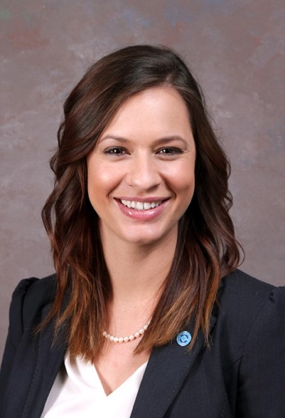
Amanda LaCerte serves as the Director of Dual Enrollment for Baton Rouge Community College and coordinator of Workforce Development programs and initiatives for high school partners. She is the former principal and school director of a career and technical high school located in Baton Rouge, Louisiana. Prior to her tenure as school principal and director, Amanda taught high school English, led district-wide professional development on data-driven instruction, was an instructional coach for alternatively certified teachers, served as the Positive Behavior Interventionist Support team chair, and coached the high school tennis team. Her passion of career and technical education and commitment to students within the communities she works makes her an asset in helping her college achieve its mission to meet the educational and workforce needs of the community.
Amanda holds a B.A. in English with a concentration in Writing and Culture, a Master’s Degree in Public Administration, both from Louisiana State University, and is a certified NCCER instructor. Amanda can be reached at (225)216-8637 or lacertea@mybrcc.edu.

