National Career Development Association
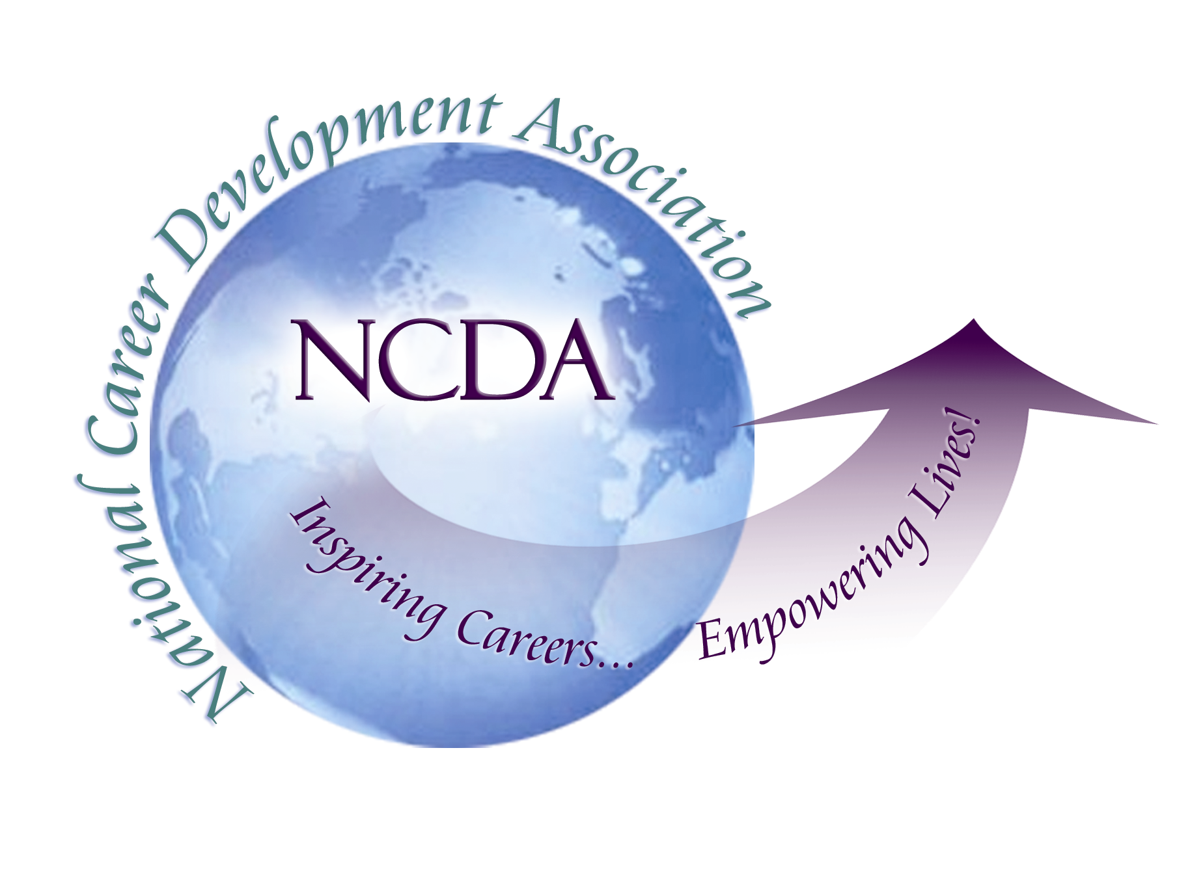
305 N. Beech Circle
Broken Arrow, OK 74012
918/663-7060
Fax: 918/663-7058
www.ncda.org

National Career Development Association
Leadership Academy
Action Learning Project Summary

Participant(s): Darren Kaltved

Board Mentor: Victor Massaglia and Elizabeth Craig

Leadership Academy Class: Class of 2015

Project Title: State CDA Board Member Orientation

Project Description: The goal of this project is to conduct a needs assessment of State CDA’s to evaluate the need and/or opportunities to enhance orientation processes. In addition, materials and training will be developed for new and returning board member orientation planning including topics as fiduciary and legal responsibilities, Roberts Rules of Order, CDA history, By-laws, board manuals, succession planning and much more. Whether your State CDA currently provides an orientation for board members or is considering the start of one, this project will provide you the research, strategic framework and tools to conduct a successful board orientation.

Summary/Conclusion:
Based on the results of my survey from state CDA’s, there exists a lack of structure, formulation and purpose regarding new and existing board member orientation, leadership development, strategic planning, and succession planning. With the assistance from NCDA, the State CDA Trustee, current state CDA leadership, and the career development community at-large, there can and needs to exist resources, tool kits and learning/professional development opportunities for state CDA’s to succeed in effectively and efficiently running a non-profit; one that impacts their local community, develops and maximizes the strengths of its board, and spotlights the great work we do as career development professionals.

Results/Recommendations:
Survey Results: Please see attachment. Recommendations for this project follow.

State CDA Board Orientation – Survey Results

Do you currently offer a formal New Board Member Orientation for your State Association? (n: 36)
YES: 4
NO: 6

Member Size | Board Size | Members/Board Member
301 | 18 | 17
138 | 10 | 14
80 | 17 | 5
200 | 17 | 12
90 | 17 | 5
160 | 16 | 10
133 | 15 | 9
75 | 7 | 11
80 | 7 | 11
Averages
140 | 14 | 10

Please mark the topics that are currently addressed in your New Board Member Orientation | Please mark all that apply
By-Laws | 4
Code of Ethics | 0
Fiduciary Responsibilities | 0
Strategic/Business Plan | 2
State Association History | 2
List of Current Board Members | 4
Yearly Events | 4
Board Structure | 3
Board/Role Responsibilities & Expectations | 5
Tax and/or Insurance Information | 0
Association Mission and Vision | 4
Committee Information | 2
Other:
We are currently having problems with succession planning. We hope to have a better process in place in the future.
While we do not have a new board member orientation. The first meeting of every new term is allocated to address and review (for older members) the items I checked off above.
Standard Operating Procedures for New Board Members
1) Add to MCDA Google email Google Drive
2) Add to website
3) Set up Orientation meeting (WebEx / TeamViewer / Google Hangout, F2F, etc…)
Board members responsible for representing members and their area
Ask clarifying, volunteer for something you are interested in and be expected to vote your mind, not just with the rest of the group
Board meetings should be reporting out work that was done outside of meeting (in general)
Each Board member responsible for contacting 8 -10 assigned members periodically to communicate events, decisions, and to hear what they have to say; Each Board member responsible for writing up a “Member Spotlight” for the newsletter (typically one / year); Each Board member responsible for finding a Featured Resource for the newsletter about once / year; and Attendance is expected at all Board meetings, typically 4 or 5 / year. One excused absence. More than that the Board must decide if we should re-open the position.

Recommendations

Below are a list of recommendations for NCDA and NCDA-affiliated state association’s regarding this project:

- NCDA: Incorporate the state association new/existing board member orientation toolkit into the State Division Leader’s Handbook. In collaboration with Wendy LaBenne, a newly elected NCDA Board of Trustee, this comprehensive resource can provide state division leaders and their associations the tools, resources and framework for establishing a successful non-profit organization that positively impacts their state membership, leadership development, career development professionals and NCDA at-large.
- Provide direct access to the New Board Member Orientation Tool Kit by sending information to current leaders of the 38 established state divisions.
- Build off of the roles and responsibilities of the Board of Trustee for State Divisions by instituting a committee or task group that serves as a direct resource, contact and support for all established and newly formed state divisions. This can include, but is not limited to, assisting NCDA with state division recognition; communicating news, information and resources to state division leaders; providing and maintaining web content on the NCDA website for state divisions; serving as a welcoming platform for newly established state divisions; assisting state divisions with identifying speakers and promoting their events or programs; and representing state divisions at NCDA board meetings and events.
- Consider incorporating the New Board Member Orientation Tool Kit into the orientation of newly elected NCDA Board Members (trustees and executive roles).
- Encourage future Leadership Academy participants to consider doing a project that focuses on expanding this tool kit and/or focuses on board functionality, succession planning, event management, fiscal responsibility, strategic planning and other topic areas for post-orientation.

